EC – DECLARATION OF CONFORMITY
Declaration according to Annex II.1.A of the Machinery Directive 2006/42/EC
This language version of the declaration is verified by the manufacturer (original declaration).

We :
Business name | : Technische Handelmaatschappij J. De Wild B.V.
Adress | : De Meeten 54, 4706 NH ROOSENDAAL
Country | : NEDERLAND

Declare for the product described below:
Generic denomination | : Woodchipper
Commercial name | : GTS1400MX
Type | : GTS1400MX
Serialno. | : __________________
Year | : 2016
Function | : Woodchipper GTS1400MX designed to shred fresh wood. Max. average diameter branches: 100mm.
Power | : Yamaha MX400, 14 hp/3600rpm.
Weight | : 190 kg.

That all the relevant provisions of the Machinery Directive are fulfilled.
That the product also complies with the following European Directives:
- 2006/42/EC | Machine Directive
- 2004/108/EC | Directive 2004/108/EC of the European Parliament and of the Council of 15 December 2004 on the approximation of the laws of the Member States relating to electromagnetic compatibility and repealing Directive 89/336/EEC
- 2002/44/EC | Directive 2002/44/EC of the European Parliament and of the Council of 25 June 2002 on the minimum health and safety requirements regarding the exposure of workers to the risks arising from physical agents (vibration) (sixteenth individual Directive within the meaning of Article 16(1) of Directive 89/391/EEC) - Joint Statement by the European Parliament and the Council
That the following harmonized standards have been used:

- EN 13525 | Forestry Machinery — Wood chippers — Safety
The conformity assessment was carried out by:
Business name | : TUV Rheinland / CCIC (Qingdao) Co., Ltd.
Adress | : 6F, No. 2 Bldg., No. 175 Zhuzhou Road, Qingdao, China
Notified Body number | : 0197
Examination number | : 17705902-001
Measured Sound Power Level L_{WA} = 95 dB(A)
Guaranteed Sound Power Level L_{WA} =113 dB(A)
Weighted Sound Pressure Level L_{pA} = 92 dB(A)

That the following natural or legal person established in the Community is authorized to compile the technical file:

Business name | : Technische Handelmaatschappij J. De Wild B.V.
Name and position | : ing. J.K. Elenbaas, CTO Europe
Adress | : De Meeten 54, 4706 NH ROOSENDAAL
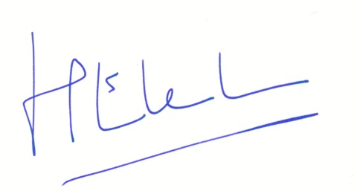  Country | : NEDERLAND

Done at Roosendaal, 10 June 2016.

ing. J.K. Elenbaas
CTO Europe

